PATHSHALA NEPAL FOUNDATION

PRE-UNI PROGRAM

Baneshwor, Kathmandu



Lab assessment report on

Problems Based on use of Nested Loop

**Submitted By:** **Submitted To**

Name: Raunak Raj Adhikari Department of Computer Science

Class: 11 PATHSHALA NEPAL FOUNDATION

Group: 1

Date: 2023-04-30

2. Answer the following questions.

a. Define nested loop. Give its importance in program development

A nested loop is a loop within a loop. It is a type of loop that is used when a program needs to repeat a set of instructions multiple times. The inner loop will run each time the outer loop runs. This allows the program to perform multiple iterations of the same set of instructions.

b. What is switching? Highlight its advantages

Switch cases in C are a type of control statement that allows a program to execute different code depending on the value of a given expression. It is a type of selection control statement that allows a program to execute different code depending on the value of a given expression.

Advantages of switch cases in C:

1. It is easier to read and understand than a series of if-else statements.

2. It is more efficient than a series of if-else statements, as it only needs to evaluate the expression once.

3. It allows for more concise code, as multiple cases can be handled with a single statement.

4. It allows for more flexibility, as the cases can be easily changed or added.

3. Write a C program to display the numeric pattern like (use nested loop).

a.

#include <stdio.h>

int main()

{

int i, j;

for(i=1; i<=5; i++)

{

for(j=1; j<=i; j++)

{

printf("%d ", j);

}

printf("\n");

}

return 0;

}

Output:

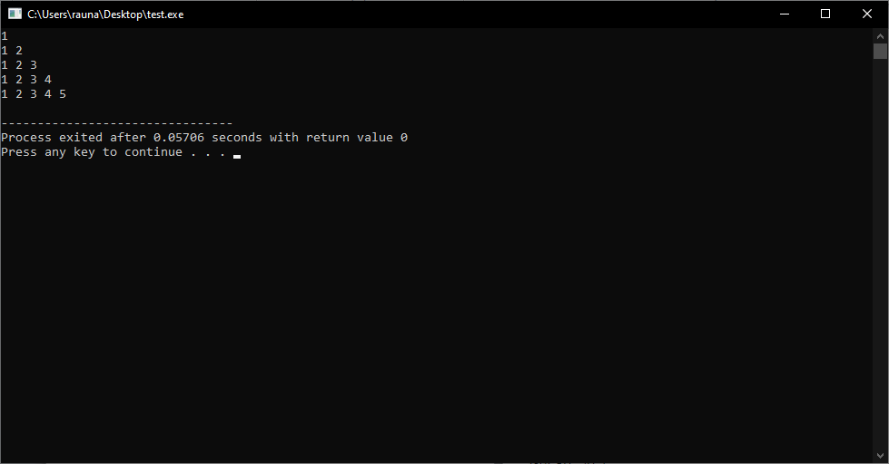

b.

#include <stdio.h>

int main()

{

int i, j;

for(i=5; i>=1; i--)

{

for(j=1; j<=i; j++)

{

printf("%d ", j);

}

printf("\n");

}

return 0;

}

Output:

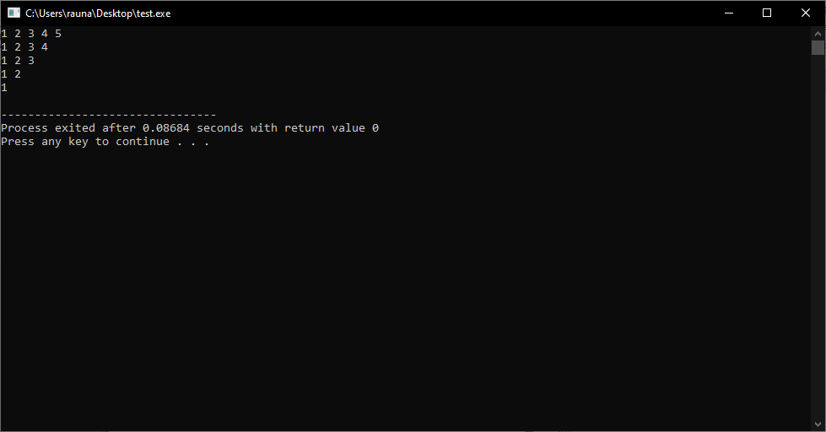

c.

#include <stdio.h>

int main()

{

int i, j;

for(i=5; i>=1; i--)

{

for(j=5; j>=i; j--)

{

printf("%d ", j);

}

printf("\n");

}

return 0;

}

Output:



d.

#include <stdio.h>

int main()

{

int i,j;

for(i=1; i<=5; i++)

{

for(j=5; j>=i; j--)

{

printf("%d ", j);

}

printf("\n");

}

return 0;

}

Output:

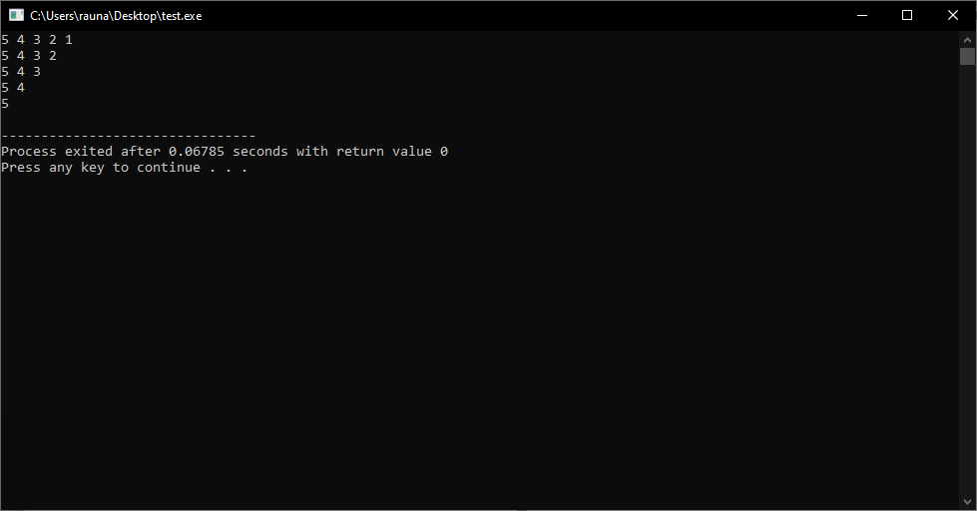

e.

#include <stdio.h>

int main()

{

int i, j;

for(i=1; i<=5; i++)

{

for(j=1; j<=i; j++)

{

printf("%d ", i);

}

printf("\n");

}

return 0;

}

Output:

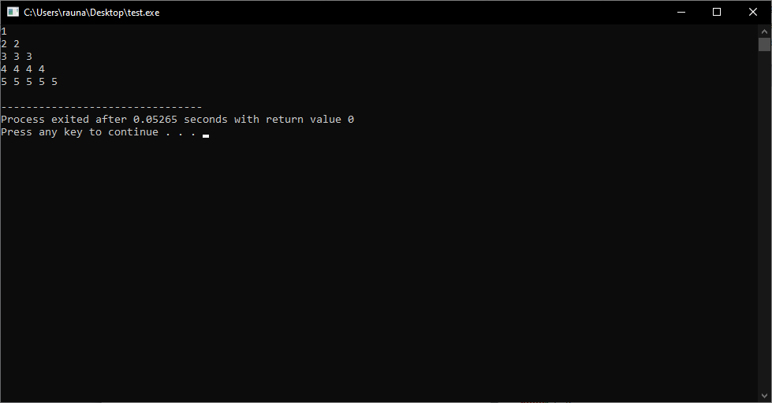

f.

#include <stdio.h>

int main()

{

int i, j;

for(i=5; i>=1; i--)

{

for(j=1; j<=i; j++)

{

printf("%d ", i);

}

printf("\n");

}

return 0;

}

Output:

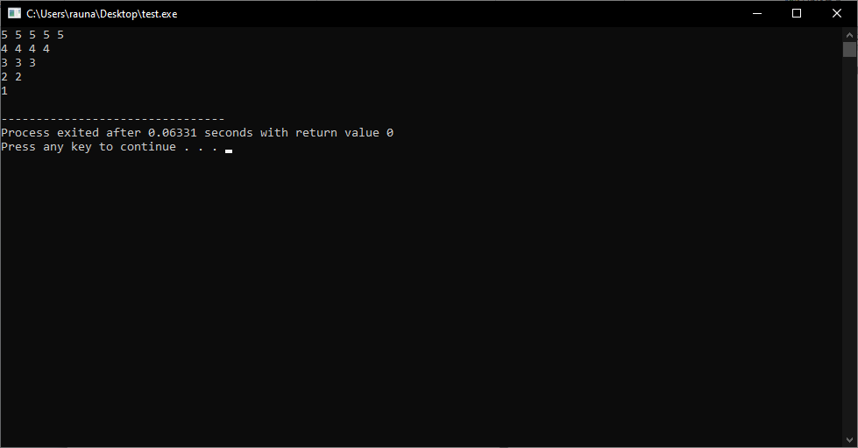

g.

#include <stdio.h>

int main()

{

int i, j;

for (i = 3; i <= 15; i += 3)

{

for (j = i; j <= i + 12; j += 3)

{

printf("%d ", j);

}

printf("\n");

}

return 0;

}

Output:

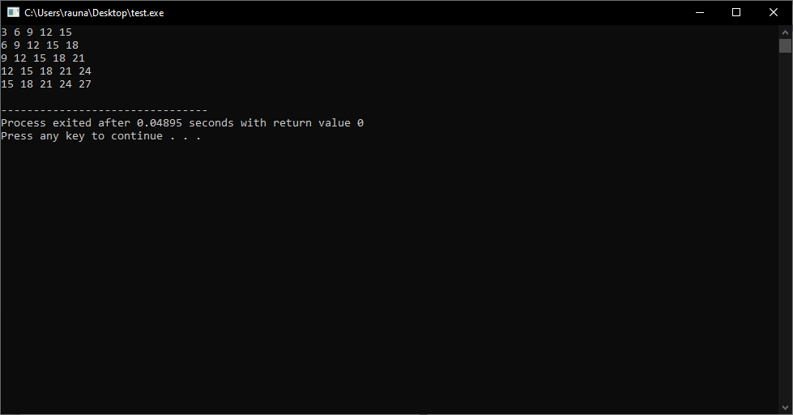

h.

#include <stdio.h>

int main()

{

int i, j;

for(i=1; i<=5; i++)

{

for(j=1; j<=i; j++)

{

printf("%d ", 2*j-1);

}

printf("\n");

}

return 0;

}

Output:

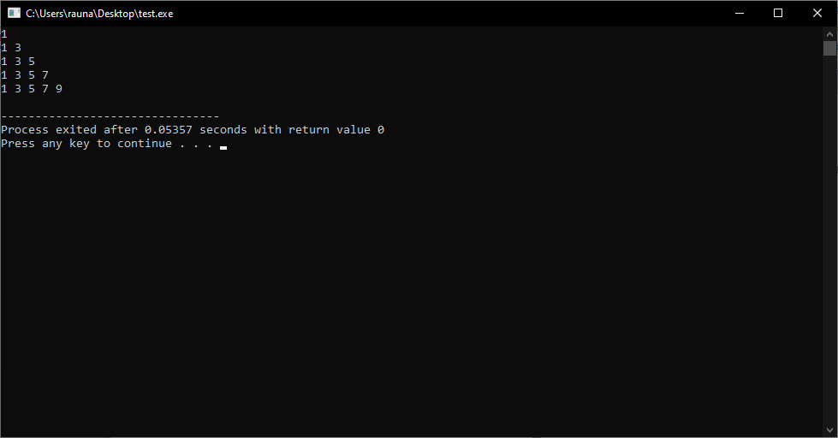

i.

#include <stdio.h>

int main()

{

int i, j;

for(i=5; i>=1; i--)

{

for(j=1; j<=i; j++)

{

printf("%d ", (2*j-1));

}

printf("\n");

}

return 0;

}

Output:

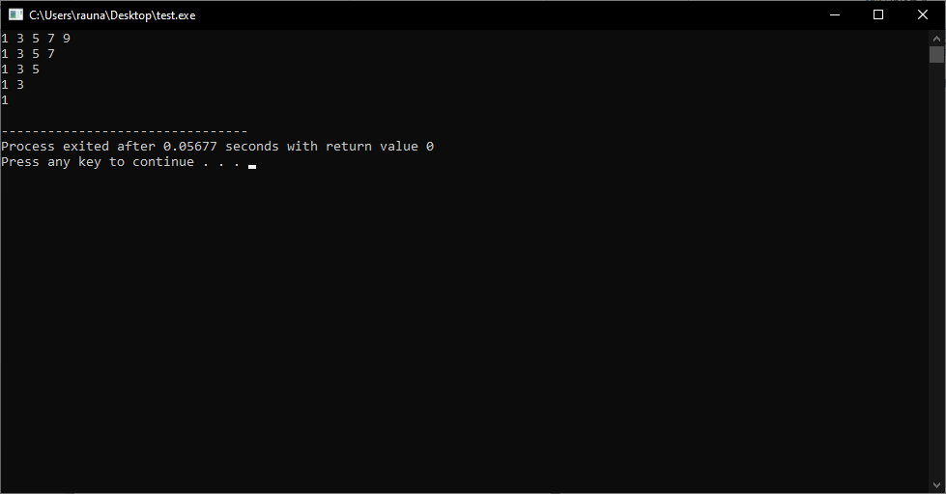

j.

#include <stdio.h>

int main()

{

int i, j;

for(i=1; i<=4; i++)

{

for(j=1; j<=i; j++)

{

printf("%d ", 2*j);

}

printf("\n");

}

return 0;

}

Output:

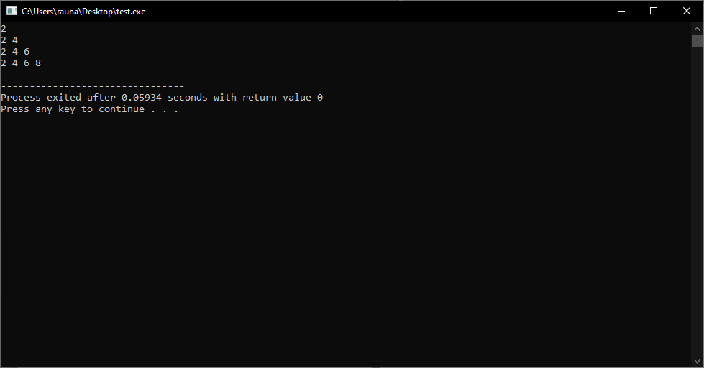

k.

#include <stdio.h>

int main()

{

int i, j;

for(i=4; i>=1; i--)

{

for(j=1; j<=i; j++)

{

printf("%d", 2*j);

}

printf("\n");

}

return 0;

}

Output:

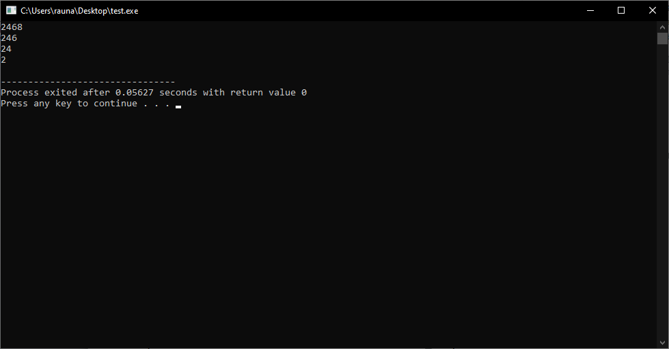

l.

#include <stdio.h>

int main()

{

int i, j;

for(i=1; i<=4; i++)

{

for(j=i; j<=i+3; j++)

{

printf("%d ", j);

}

printf("\n");

}

return 0;

}

Output:

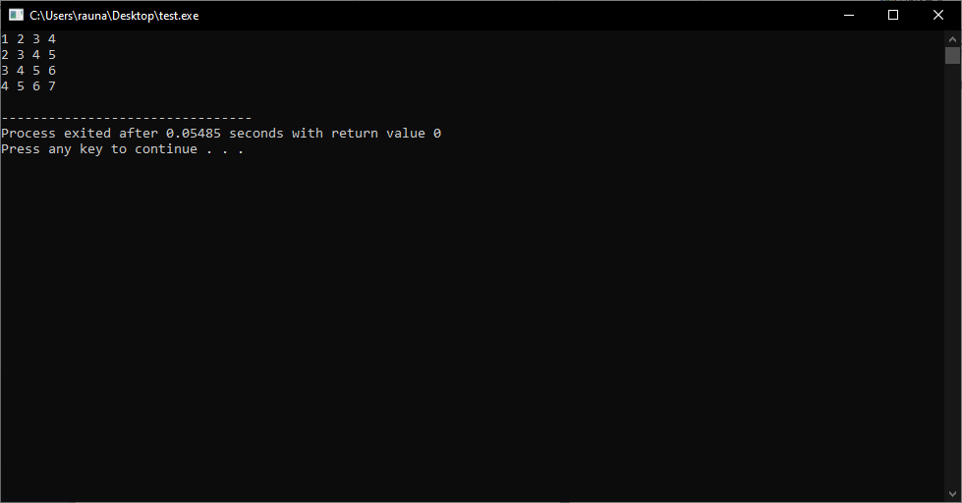

m.

#include <stdio.h>

int main()

{

int i, j;

for(i=1; i<=4; i++)

{

for(j=1; j<=5; j++)

{

printf("%d ", i*j);

}

printf("\n");

}

return 0;

}

Output:

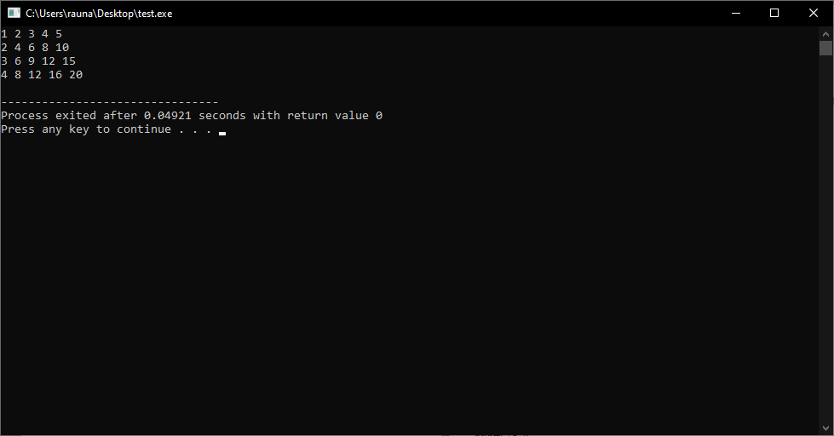

n.

#include <stdio.h>

int main()

{

int i, j;

for(i=1; i<=5; i++)

{

for(j=1; j<=i; j++)

{

printf("%c ", 64+j);

}

printf("\n");

}

return 0;

}

Output:



o.

#include <stdio.h>

int main()

{

int i, j;

for(i=5; i>=1; i--)

{

for(j=1; j<=i; j++)

{

printf("%c ", 64+j);

}

printf("\n");

}

return 0;

}

Output:

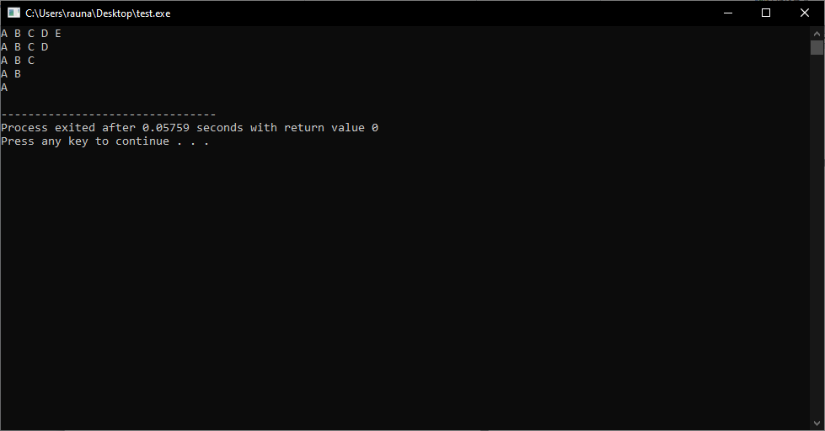

p.

#include <stdio.h>

int main()

{

int i, j;

for(i=5; i<=30; i+=5)

{

if(i!=15){

for(j=i; j<i+25; j+=5)

{

printf("%d ", j);

}

printf("\n");

}

}

return 0;

}

Output:

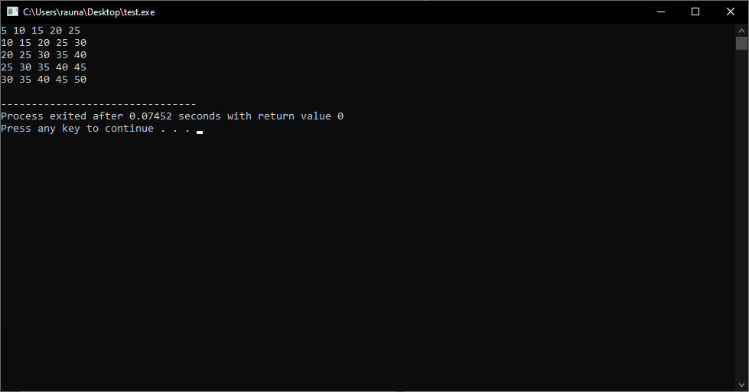

q.

#include <stdio.h>

int main()

{

int i, j;

for(i=1; i<=8; i=i*2)

{

for(j=1; j<=5; j++)

{

printf("%d\t", i*j);

}

printf("\n");

}

return 0;

}

Output:

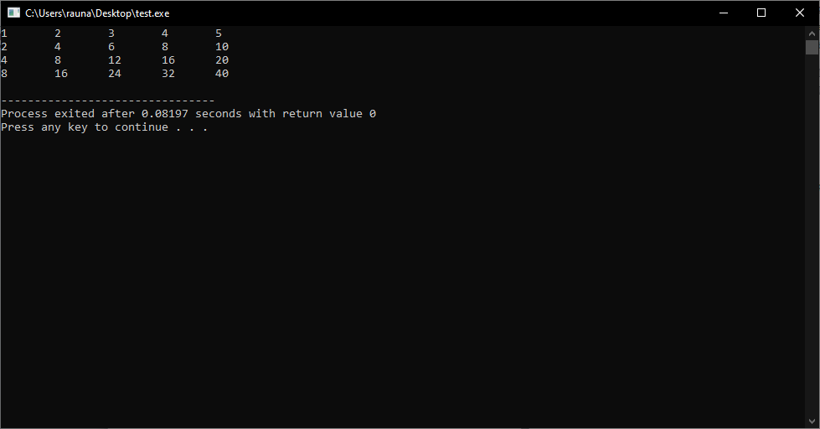

4. To display the multiplication table fo 1 to 10 with 10 multiples of each.

#include <stdio.h>

int main()

{

int i, j;

printf("Multiplication Table from 1 to 10\n\n");

for(i=1; i<=10; i++)

{

for(j=1; j<=10; j++)

{

printf("%d x %d = %d\n", i, j, i*j);

}

printf("\n");

}

return 0;

}

Output:

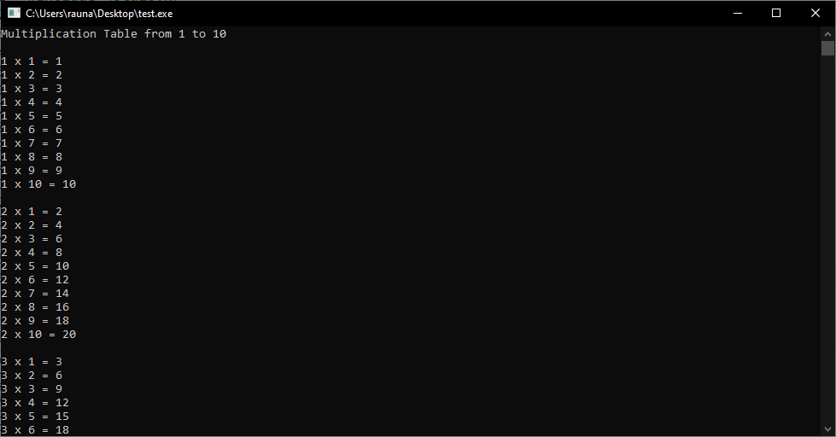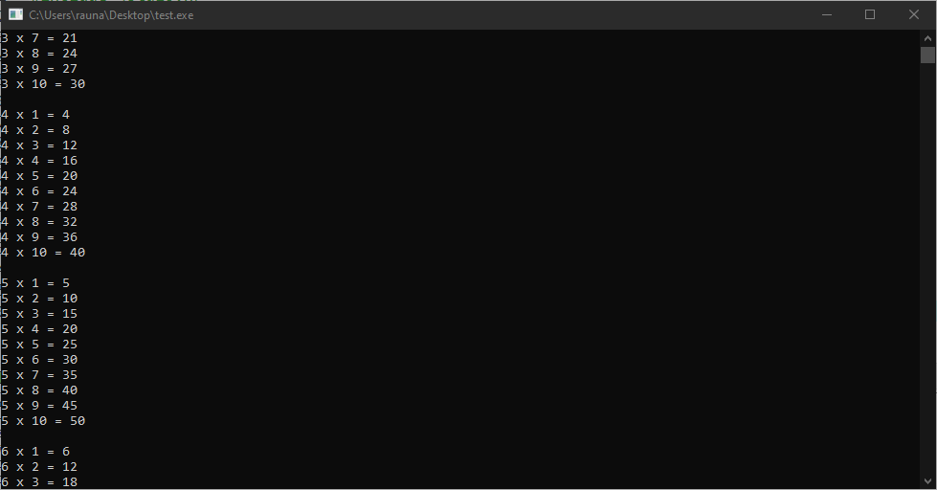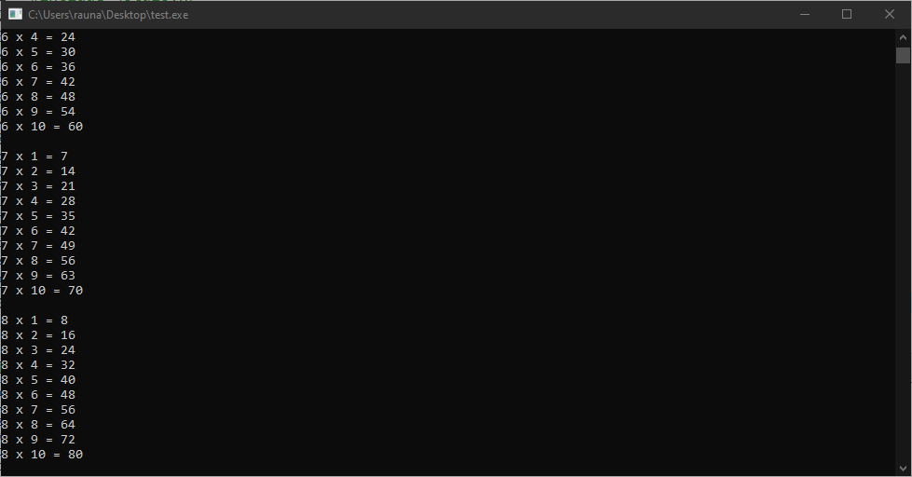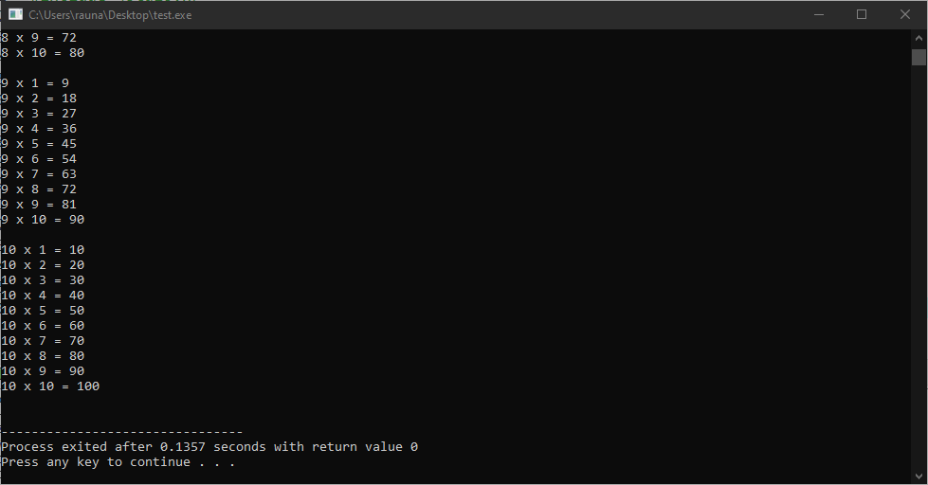

5.

#include <stdio.h>

int main()

{

int choice;

float length, breadth, height;

float area, volume, total_surface_area;

printf("Please enter your choice:\n");

printf("1. Calculate area of 4 walls of a room\n");

printf("2. Calculate volume of a cuboid\n");

printf("3. Calculate total surface area of a room\n");

scanf("%d", &choice);

switch(choice)

{

case 1:

printf("Please enter the length, breadth and height of the room:\n");

scanf("%f %f %f", &length, &breadth, &height);

area = 2 * (length * height + breadth * height);

printf("The area of 4 walls of the room is %.2f\n", area);

break;

case 2:

printf("Please enter the length, breadth and height of the cuboid:\n");

scanf("%f %f %f", &length, &breadth, &height);

volume = length * breadth * height;

printf("The volume of the cuboid is %.2f\n", volume);

break;

case 3:

printf("Please enter the length, breadth and height of the room:\n");

scanf("%f %f %f", &length, &breadth, &height);

total_surface_area = 2 * (length * breadth + breadth * height + height * length);

printf("The total surface area of the room is %.2f\n", total_surface_area);

break;

default:

printf("Invalid choice!\n");

break;

}

return 0;

}

Output:

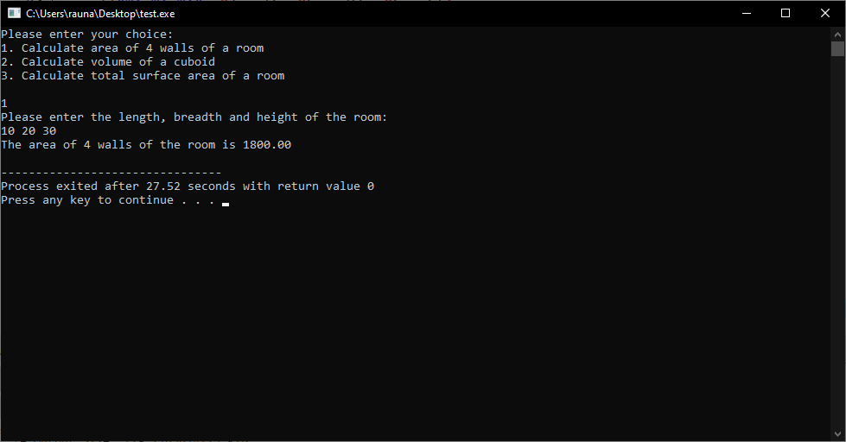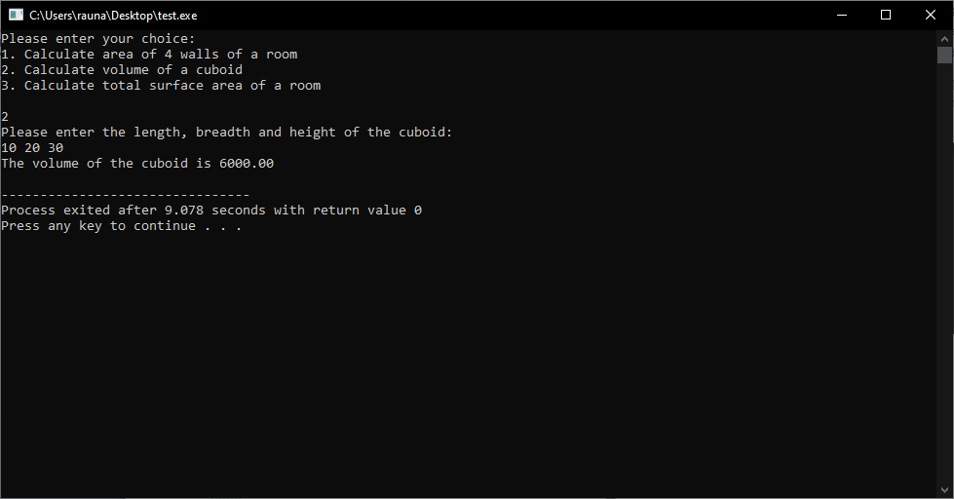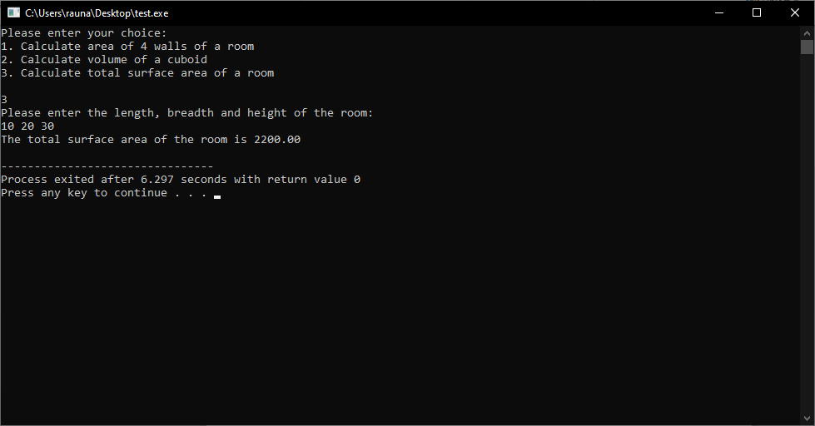

6.

#include <stdio.h>

int main()

{

int choice;

float temp, fahrenheit, celcius;

printf("Choose the conversion type:\n");

printf("1. Celsius to Fahrenheit\n");

printf("2. Fahrenheit to Celsius\n");

scanf("%d", &choice);

switch(choice)

{

case 1:

printf("Enter temperature in Celsius: ");

scanf("%f", &temp);

fahrenheit = (temp * 9/5) + 32;

printf("Temperature in Fahrenheit: %.2f\n", fahrenheit);

break;

case 2:

printf("Enter temperature in Fahrenheit: ");

scanf("%f", &temp);

celcius = (temp - 32) * 5/9;

printf("Temperature in Celsius: %.2f\n", celcius);

break;

default:

printf("Invalid Choice\n");

break;

}

return 0;

}

Output:

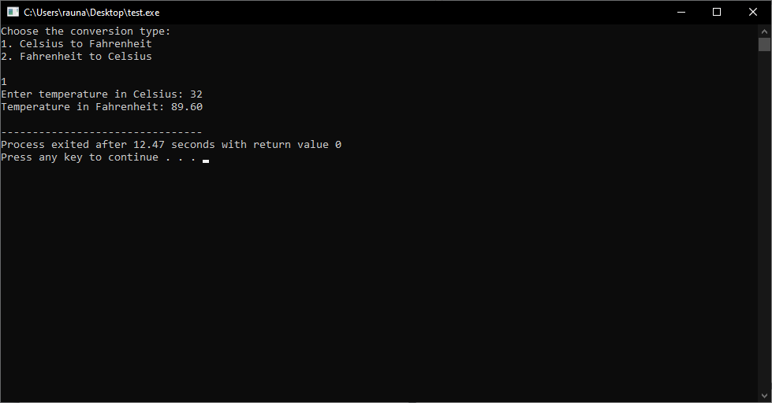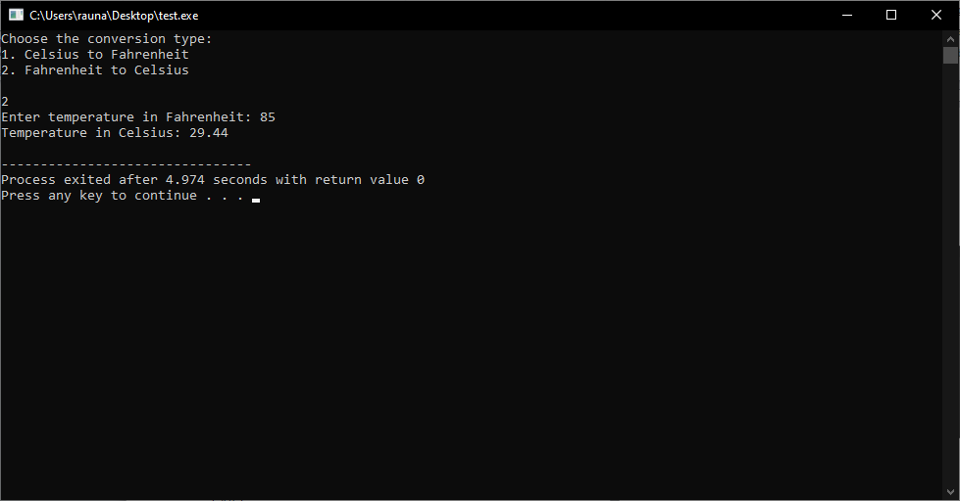

7.

#include <stdio.h>

int main()

{

int num1, num2, num3, choice;

printf("Enter three numbers: ");

scanf("%d %d %d", &num1, &num2, &num3);

printf("Enter your choice: \n1. Find largest value\n2. Find smallest value\n3. Find median value\n");

scanf("%d", &choice);

switch(choice)

{

case 1:

if(num1 > num2 && num1 > num3){

printf("Largest value is %d", num1);

}

else if(num2 > num1 && num2 > num3){

printf("Largest value is %d", num2);

}

else{

printf("Largest value is %d", num3);

}

break;

case 2:

if(num1 < num2 && num1 < num3){

printf("Smallest value is %d", num1);

}

else if(num2 < num1 && num2 < num3){

printf("Smallest value is %d", num2);

}

else{

printf("Smallest value is %d", num3);

}

break;

case 3:

if((num1 > num2 && num1 < num3) || (num1 > num3 && num1 < num2)){

printf("Median value is %d", num1);

}

else if((num2 > num1 && num2 < num3) || (num2 > num3 && num2 < num1)){

printf("Median value is %d", num2);

}

else{

printf("Median value is %d", num3);

}

break;

default:

printf("Invalid choice");

break;

}

return 0;

}

Output:

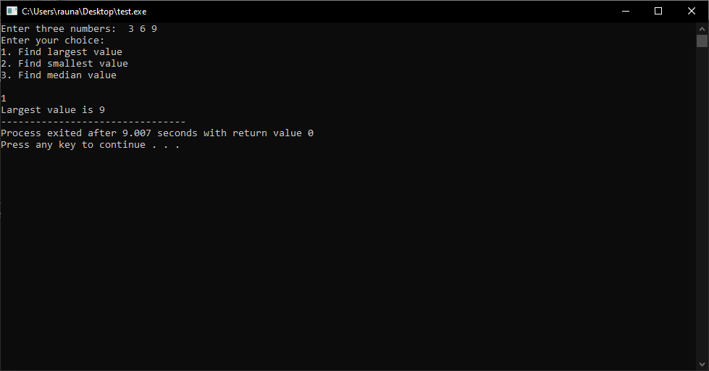

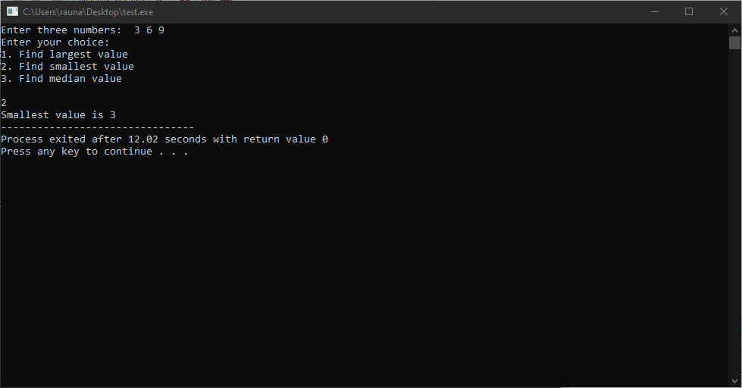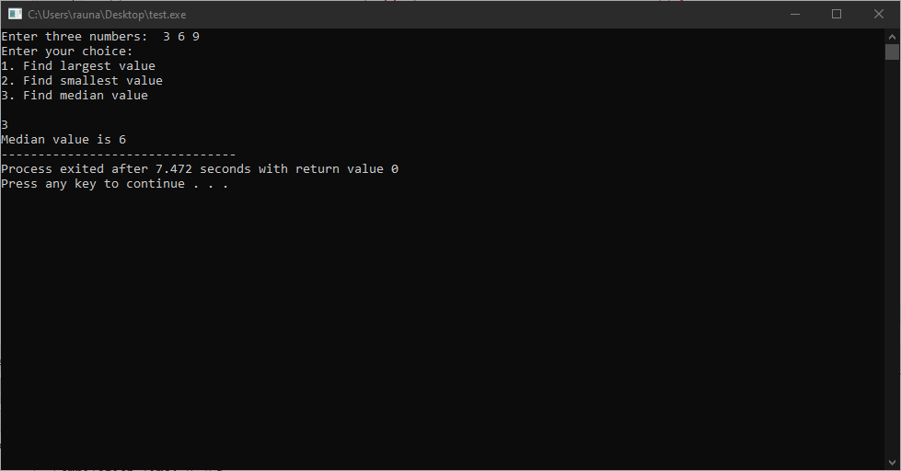

8.

#include <stdio.h>

int main()

{

char color;

printf("Choose your favorite color: \n");

printf("Press R for Red\n");

printf("Press G for Green\n");

printf("Press B for Blue\n");

printf("Press Y for Yellow\n");

scanf("%c", &color);

switch(color)

{

case 'R':

case 'r':

printf("You have chosen Red Color\n");

break;

case 'G':

case 'g':

printf("You have chosen Green Color\n");

break;

case 'B':

case 'b':

printf("You have chosen Blue Color\n");

break;

case 'Y':

case 'y':

printf("You have chosen Yellow Color\n");

break;

default:

printf("Invalid Choice\n");

break;

}

return 0;

}

Output:

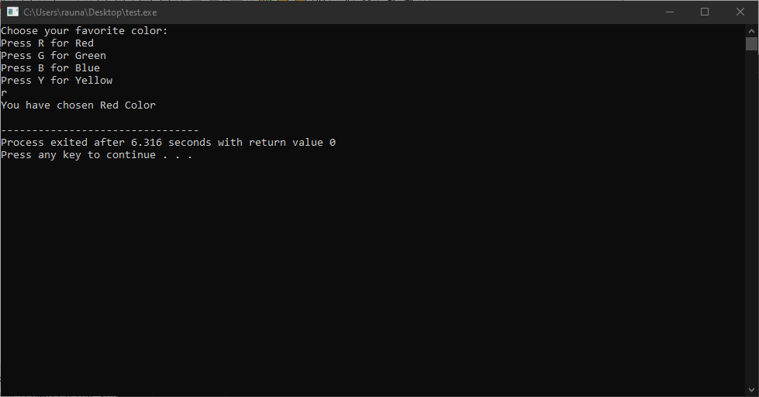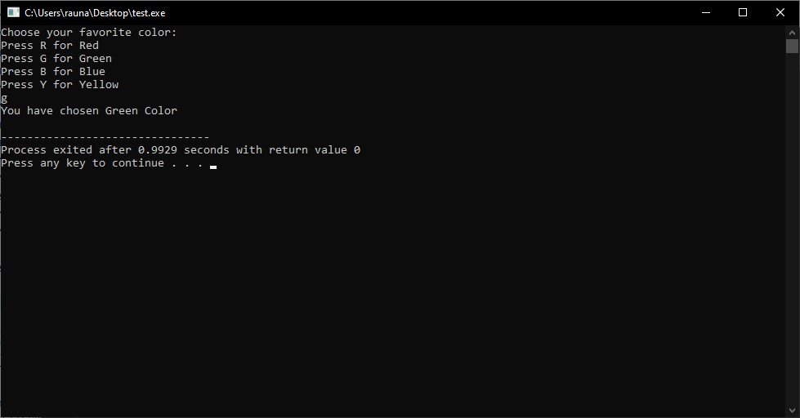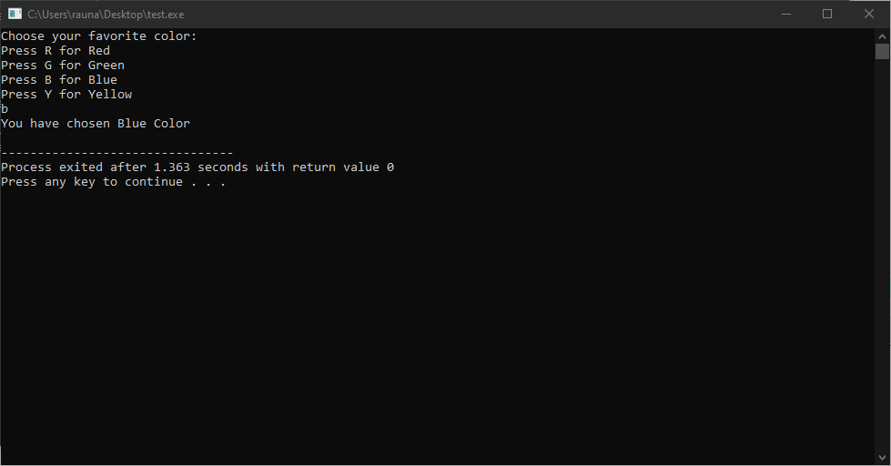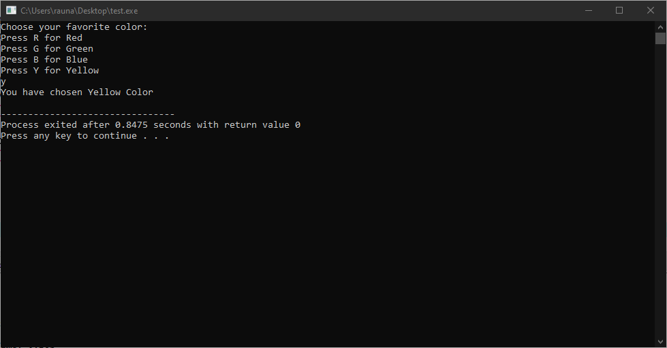

9.

#include <stdio.h>

#include <math.h>

int main()

{

int choice;

float radius, volume, area, circumference;

printf("Please enter your choice:\n");

printf("1. Calculate volume of a sphere\n");

printf("2. Calculate area of a sphere\n");

printf("3. Calculate circumference of a sphere\n");

scanf("%d", &choice);

printf("Please enter the radius of the sphere: ");

scanf("%f", &radius);

switch(choice)

{

case 1:

volume = (4.0/3.0) * M_PI * pow(radius, 3);

printf("The volume of the sphere is %f\n", volume);

break;

case 2:

area = 4 * M_PI * pow(radius, 2);

printf("The area of the sphere is %f\n", area);

break;

case 3:

circumference = 2 * M_PI * radius;

printf("The circumference of the sphere is %f\n", circumference);

break;

default:

printf("Invalid choice!\n");

break;

}

return 0;

}

Output:

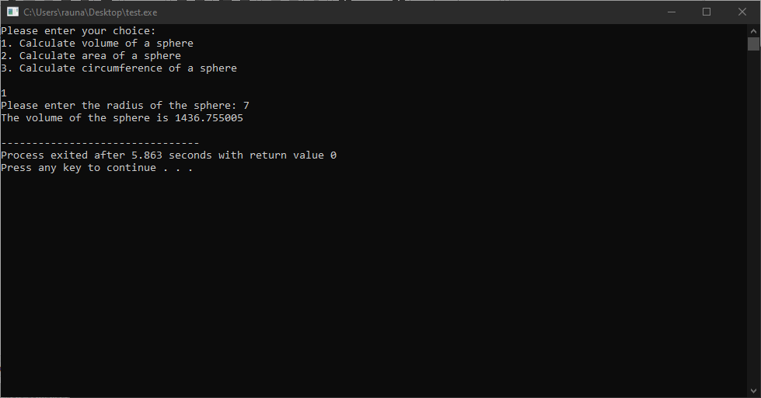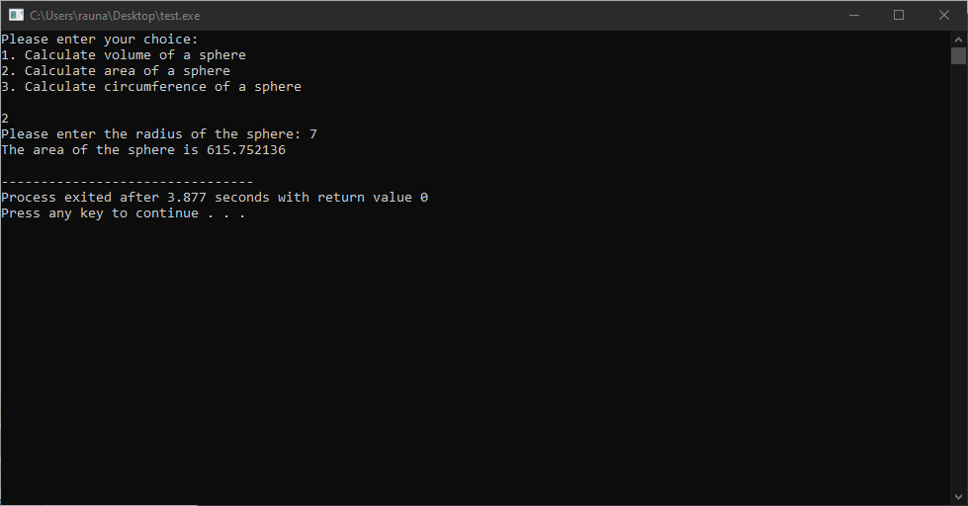

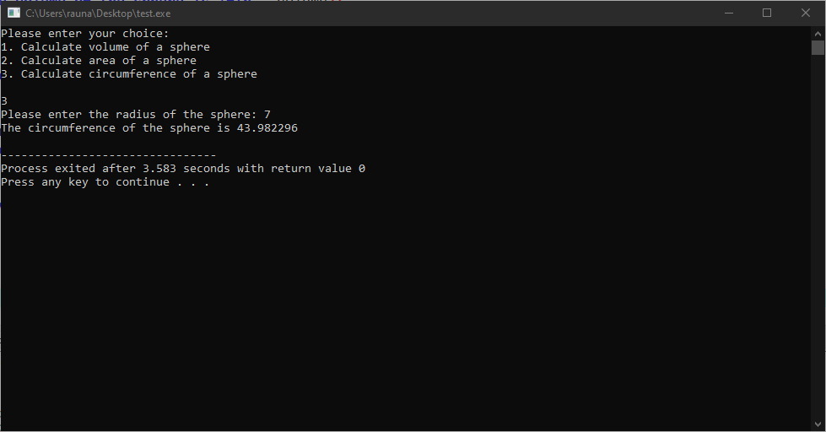

10.

#include <stdio.h>

int main()

{

int num, i, flag = 0;

int rem, temp, sum = 0;

int rev = 0;

printf("Enter a positive integer: ");

scanf("%d", &num);

int choice;

printf("Enter your choice: \n1. Prime or Composite \n2. Palindromic or Not \n3. Armstrong or Not \n");

scanf("%d", &choice);

switch (choice)

{

case 1:

for (i = 2; i <= num / 2; ++i)

{

if (num % i == 0)

{

flag = 1;

break;

}

}

if (flag == 0){

printf("%d is a prime number.", num);

}

else{

printf("%d is not a prime number.", num);

}

break;

case 2:

temp = num;

while (temp != 0)

{

rem = temp % 10;

rev = rev * 10 + rem;

temp /= 10;

}

if (rev == num){

printf("%d is a palindromic number.", num);

}

else{

printf("%d is not a palindromic number.", num);

}

break;

case 3:

temp = num;

while (temp != 0)

{

rem = temp % 10;

sum += rem * rem * rem;

temp /= 10;

}

if (sum == num){

printf("%d is an Armstrong number.", num);

}

else{

printf("%d is not an Armstrong number.", num);

}

break;

default:

printf("Invalid Choice");

break;

}

return 0;

}

Output:

